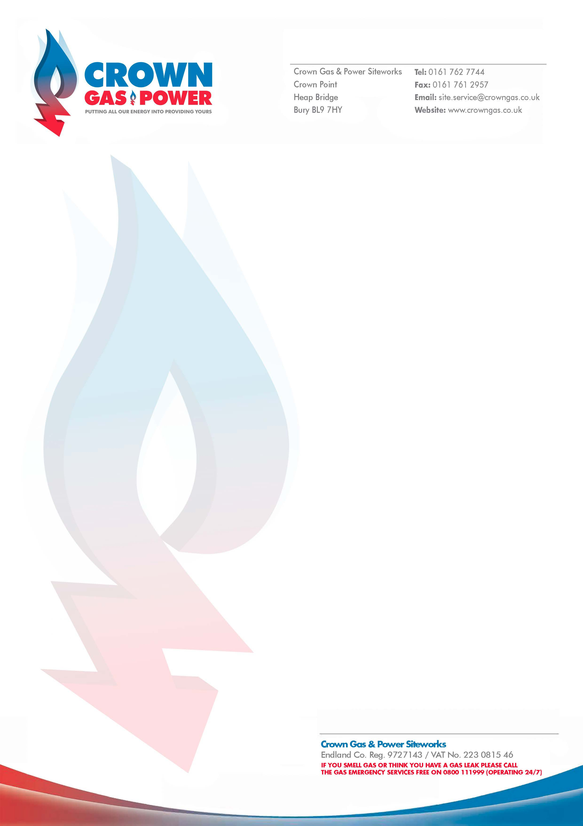
VAT reverse charge for building and construction services

From 1st March 2021, the way VAT is charged within the construction industry is changing. Please read and complete page two of this document for every job completed with Crown Gas & Power Siteworks Ltd.

What is the reverse charge?
- If you're a main contractor, unless you can opt to be an end user, you'll stop paying VAT to subcontractors working on projects where the Construction Industry Scheme (CIS) applies. Instead, you'll pay the VAT directly to HM Revenue and Customs (HMRC).
- If you’re a subcontractor, this will affect your cash flow, as it will reduce the gross amount that you charge to your main contractor.

Who it affects
Whether you're a main contractor or subcontractor, the VAT reverse charge will affect you if both of the following apply:
- You work on any contract covered by the CIS
- Both you and your main contractor or subcontractor are VAT-registered businesses
If your subcontractors are not registered for UK VAT, or your supplies are zero-rated, then the reverse charge will not affect you. Nor will it apply to end user customers. If the VAT reverse charge applies to you, you must get ready now.

What you need to do
- Use the flowchart on the next page to check if the VAT reverse charge will affect you
- If it does, and payments are under a contract that continues after 1 March 2021, ask your subcontractors and/or contractors about their CIS, end user and VAT registration status,
if you do not already know this
- Talk to the people that help you invoice for work or manage your VAT, so they can update your accounting systems to apply the correct treatment from 1 March 2021.

Cashflow and VAT deferral
If you're a subcontractor, this change will affect your cash flow as it will reduce the gross amount that you charge to your customers. For options on how to pay any deferred VAT, or if you need extra help with paying other taxes, go to GOV.UK and search - ‘VAT deferral’.

Further information
- Go to GOV.UK and search for ‘VAT reverse charge for building and construction services’

Company name – Click or tap here to enter text.
Date – Click or tap to enter a date.
CGPS Reference – Click or tap here to enter text.
Please state the applicable VAT charge - Select here
If normal VAT rules apply, please state the reason for choosing this – Choose an item.
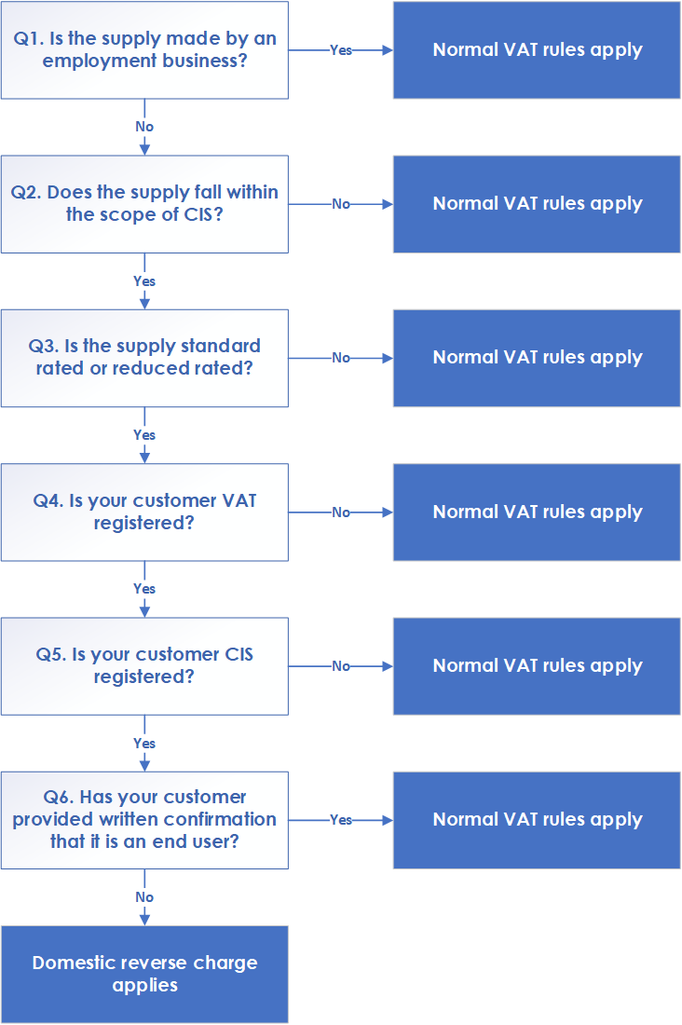
Use this flowchart to see how you would decide whether to apply normal VAT rules or apply the reverse charge to your supplies. Once you have established this information, please fill in the section at the bottom of the page and return to siteworks.services@crowngas.co.uk

